**Software Requirements Specification**

**For**

**VL-Solution CCTV**

**Prepared by Vimukthi Lakshan**

**[200010200450]**

**V Company**

**8/2023**

* **Introduction to a Point of Sale**

1. Purpose:

The Point of Sale (POS) System is a software solution designed to facilitate efficient and accurate sales transactions, inventory management, and business operations for VL-Solution. This SRS document outlines the functional and non-functional requirements for the development and implementation of the POS system.

1. Scope:

The POS system will cover all aspects of sales processing, inventory management, payment handling, reporting and analytics, customer management, and employee management for [Your Company Name]. It will be deployed at all Colombo and will serve as a vital tool for [Retail/Service] operations.

1. Overview:

The POS system is intended to provide a comprehensive and user-friendly platform for VL-Solution employees to efficiently manage sales and inventory. It will enable quick and secure payment processing, generate real-time reports, enhance customer interactions, and streamline employee management.

1. System Description:

The POS system will consist of both software and hardware components. It will be accessible through dedicated terminals and may include mobile capabilities for Sale. The software will run on [Operating System(s)] and will be designed using java.

1. Users:

The primary users of the POS system include [User Roles, e.g., Cashiers, Managers, Admins] at Colombo Customers will also interact with the system during the checkout process.

1. Functional Requirements:

This section will detail the specific functions and capabilities of the POS system, including sales processing, inventory management, payment handling, reporting, customer management, and employee management.

1. Non-Functional Requirements:

Non-functional requirements, such as performance, security, scalability, and usability, will be defined to ensure the system meets VL-Solution standards and industry best practices.

1. Constraints:

Any limitations or constraints, such as budget, timeline, or hardware compatibility, will be outlined in this section.

1. Assumptions and Dependencies:

This section will list any assumptions made during the development process and any external dependencies required for the successful implementation of the POS system.

1. Glossary:

A glossary of terms and acronyms used throughout the SRS document will be provided for clarity and reference.

**TABLE OF CONTENTS**

**PROBLEM STATEMENT**

Problem Statement:

VL-Solution operates a [type of business, e.g., retail store, restaurant, hotel] and currently faces several challenges in its day-to-day operations related to sales processing, inventory management, and overall business efficiency. These challenges include:

**Inefficient Sales Processing:** The existing manual or outdated POS system results in slow and error-prone sales processing, leading to customer dissatisfaction and lost revenue opportunities.

**Inventory Management Issues:** [Your Company Name] struggles to maintain accurate real-time inventory records, resulting in overstocking or stockouts, increased holding costs, and missed sales opportunities.

**Limited Business Insights**: The lack of a robust reporting and analytics system makes it challenging for [Your Company Name] to gain insights into sales trends, customer preferences, and overall business performance.

**Customer Experience**: Customers often experience delays during the checkout process, and the limited ability to offer loyalty programs or personalized promotions hinders customer engagement and retention.

**Employee Management:** Managing employee access, performance tracking, and commissions manually poses administrative challenges and potential errors.

**Objectives**: The primary objectives of implementing a new POS system for VL-Solution are as follows:

**Efficiency and Accuracy:** Develop a POS system that streamlines sales processing, reduces errors, and ensures a faster and more accurate checkout process for customers.

**Inventory Control**: Implement a comprehensive inventory management system to maintain accurate stock records, reduce holding costs, and improve supply chain management.

**Data-Driven Insights**: Create a robust reporting and analytics platform that provides valuable insights into sales trends, inventory turnover, and customer behavior to support informed decision-making.

**Enhanced Customer Experience**: Improve customer satisfaction by enabling faster checkouts, providing personalized promotions, and implementing loyalty programs.

**Employee Management**: Simplify employee management through user-friendly interfaces, access controls, and performance tracking features.

**Scope:**

The scope of this project is to design, develop, and implement a modern POS system tailored to the specific needs of VL-Solution. The system will cover all aspects of sales processing, inventory management, reporting, and customer engagement for colombo.

**Constraints:**

* Budget: The project budget is limited to 50thousand.
* Timeline: The system must be fully operational within 3Months.
* Hardware Compatibility: The POS system should be compatible with existing hardware [if applicable].

**Assumptions:**

* VL-Solution assumes that the new POS system will lead to increased operational efficiency, improved customer satisfaction, and higher revenue.
* The project assumes that necessary hardware upgrades [if required] will be completed on schedule.

**Dependencies:**

* Successful implementation of the POS system depends on timely acquisition of any required hardware or software licenses.
* Training for employees on using the new system is a crucial dependency.

**OBJECTIVES**

**Efficiency and Accuracy:**

To streamline sales processing, reducing transaction times and minimizing errors, resulting in an efficient and accurate checkout experience for customers.

**Inventory Control:**

To maintain precise, real-time inventory records, optimizing stock levels, reducing holding costs, and ensuring products are consistently available for customers.

**Data-Driven Insights:**

To create a robust reporting and analytics platform that provides actionable insights into sales trends, product performance, and customer behavior, empowering data-driven decision-making.

**Enhanced Customer Experience:**

To enhance customer satisfaction by providing a faster, hassle-free checkout process and enabling the implementation of personalized promotions and loyalty programs.

**Employee Management:**

To simplify employee management through user-friendly interfaces, access controls, and performance tracking features, improving overall operational efficiency.

**Security and Compliance:**

To ensure the security and compliance of the POS system with industry standards and regulations, safeguarding customer and financial data.

**Scalability:**

To design the POS system with scalability in mind, allowing for easy expansion to accommodate future growth and additional features.

**Integration:**

To integrate the POS system seamlessly with existing business processes, including accounting, customer relationship management (CRM), and supply chain management systems, to create a cohesive and efficient operational environment.

**User Training:**

To provide comprehensive training and support for employees to ensure effective utilization of the POS system, minimizing disruption during the transition phase.

**Cost Efficiency:**

To manage project costs effectively, optimizing the allocation of resources to ensure that the implementation remains within budgetary constraints.

**LITERATURE REVIEW**

**SALES AND INVENTORY MANAGEMENT SYSTEM: HISTORY AND CONCEPTS**

Each day, millions of people take part in countless sales transactions across the globe, creating a constant flow of value which forms the backbone of our economies. In general, sales mean a transaction that takes place between two parties where the buyer receives goods (tangible or intangible), service or assets in exchange for money. Thus, the process requires each party to give up something in return for something valuable for them. On the other hand, inventory means the raw materials, work-in-process goods and finished goods that are the portion of a business’s assets that are ready for sales. This explains that, business needs inventory available to make sales to the customer in return for money which will generate the profits. There are two kinds of problem that are faced by business in managing inventory level which are high inventory and low inventory. Holding a high level of inventory for long periods of time is not usually good for a business due to costs incur for inventory storage, obsolescence, and spoilage. On the other hand, low level of inventory is not good either as the business may face the risk of losing potential sales and potential market share as well. In an attempt of resolving inventory problems, the solution lies on efficient inventory management. Tim Crosby (2012) in his study on ‘How Inventory Management Systems Work’ stated that inventory management system is the rule in knowing which products are selling and which are taking up shelf space for enterprises as well as smaller businesses and vendors. The system balances the goal of ensuring customers always have enough of what they want against a retailer’s financial need to maintain as little stock as possible (Tim Zierden,2009)

**ADVANTAGES OF SALES AND INVENTORY MANAGEMENT SYSTEM**

**Enhanced Efficiency:**

Streamlines sales processes, reducing transaction times, and minimizing errors during checkout. Automates inventory management tasks, such as tracking stock levels and reordering, leading to more efficient supply chain operations.

**Accurate Inventory Tracking:**

Maintains real-time, accurate inventory records, reducing the risk of overstocking or stockouts. Enables precise demand forecasting and optimized stock levels.

**Data-Driven Decision-Making:**

Provides comprehensive data and analytics on sales trends, customer behavior, and product performance, aiding in informed decision-making. Helps identify top-selling products and opportunities for targeted marketing and promotions.

**Improved Customer Experience:**

Enables faster and smoother checkouts, enhancing customer satisfaction. Allows for the implementation of loyalty programs and personalized promotions, increasing customer engagement and retention.

**Employee Efficiency:**

Simplifies employee management through user-friendly interfaces, reducing administrative tasks. Supports performance tracking, commission calculations, and access controls, enhancing operational efficiency.

**Security and Compliance:**

Ensures the security of customer and financial data through encryption and access controls, maintaining regulatory compliance. Reduces the risk of fraud and data breaches.

**Scalability:**

Designed to accommodate growth, making it easy to expand the system as the business evolves. Adapts to changing needs and additional features seamlessly.

**Integration:**

Seamlessly integrates with existing business systems, improving overall operational efficiency. Syncs with accounting, CRM, and supply chain management systems for a cohesive workflow.

**Cost Savings:**

Reduces costs associated with manual inventory management, including labor and holding costs. Minimizes errors and discrepancies that can lead to financial losses.

**Competitive Advantage:**

Positions v-solution as a more efficient and customer-centric business in the industry. Attracts and retains customers through improved service and personalized experiences.

**Business Insights:**

Offers deep insights into business performance through customizable reports and dashboards. Enables strategic planning and the identification of growth opportunities.

**METHODOLOGY**

**RAPID APPLICATION DEVELOPMENT (RAD) METHODOLOGY**

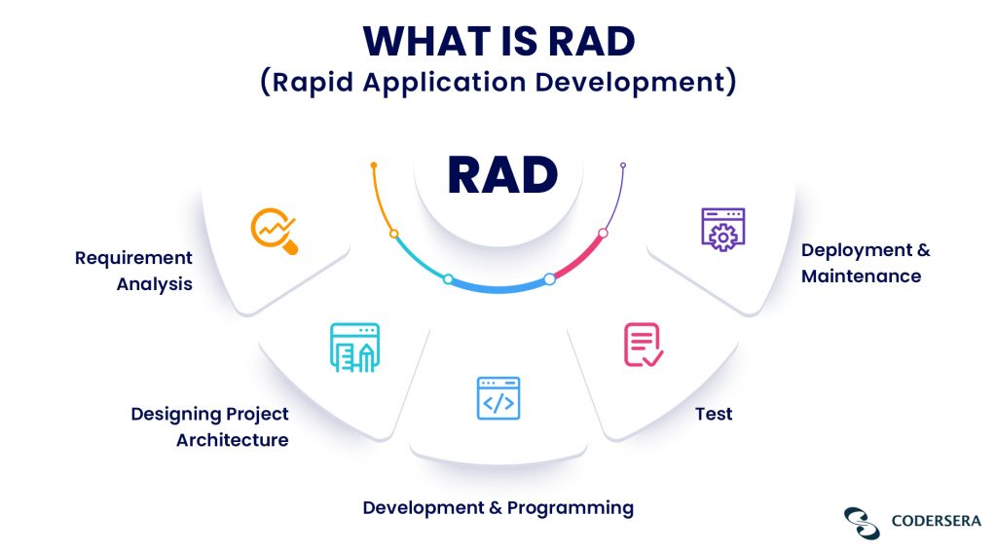

**Figure : 1**

**Iterative and Incremental:**

RAD is iterative and incremental in nature, meaning that it breaks the project into smaller, manageable components or modules that can be developed and tested independently. These modules are built iteratively, with each iteration adding new functionality.

**Prototyping:**

Prototyping is a fundamental concept in RAD. Developers create a quick, working prototype of the software to provide stakeholders with a tangible representation of the system's functionality and design. This prototype evolves with each iteration based on feedback.

**Rapid Feedback and User Involvement:**

RAD encourages continuous communication and collaboration between developers, users, and stakeholders. Users are actively involved in the design and testing process, providing feedback that guides the development.

**Time-Boxed Development:**

RAD projects are typically time-boxed, meaning that specific timeframes are allocated for each iteration. This time constraint helps maintain focus and ensures that development progresses rapidly.

**Reusable Components:**

RAD promotes the use of reusable components and pre-built templates to expedite development. These components can be leveraged across different projects, reducing development time and effort.

**Flexibility and Adaptability:**

RAD is well-suited for projects where requirements may change or evolve over time. It allows for flexibility in accommodating changing needs and priorities.

**Emphasis on User Interface (UI):**

RAD places a strong emphasis on creating a user-friendly and visually appealing UI. This is crucial for engaging users and gathering meaningful feedback early in the development process.

**Risk Management:**

The iterative approach of RAD allows for early identification and mitigation of project risks. Issues and challenges can be addressed in subsequent iterations.

**Phases of RAD:**

The RAD process typically includes four phases: Requirements Planning: Identify project objectives and requirements. User Design: Create a quick prototype of the system. Construction: Develop the software based on the prototype. Cutover: Transition the application into production.

**Tools and Technologies:**

RAD often leverages modern development tools and technologies that support rapid development, such as low-code or no-code platforms.

**Examples of RAD Methodologies:**

Some popular RAD methodologies and frameworks include Rapid Application Development (RAD), Dynamic Systems Development Method (DSDM), and Agile.

**System Request- Sales and Inventory Management System**

* **Project Sponsor**

The person who initiates the project is the owner of VSolution Furniture and the workers together with the owner serves as the primary point of contact for the project.

* **Business Need**

This project has been initiated to develop Sales and Inventory Management System to provide a better way of inventory control and tracking therefore store can manage the movement of goods more efficiently.

* **Business Requirement** The system will be the first system used by VSolution Furniture thus it will be made as offline system. The system provides enables the owner to keep track on the inventory level of each good with presents of database. The functionalities that the system should have been as follows
* User log in
* Admin log in
* Process sales
* Update inventory database based on POS
* Send Purchase Order
* Create Goods Receive Note
* Create Good Return Note
* Generate report on Sales
* Notify on low inventory level
* **Business Value**

Author expected that with this system, the users able to process customer transaction easily with minimal error or zero error. Furthermore, it is going to be more efficient in managing inventory and sales data because all data in available in database.

* **Special Issues or Constraints**

VSolution Furniture needs to familiarize in using the new system in their day to day business activities

**Feasibility Analysis**

1. **Technical Feasibility**

Technical aspect is the most important part in the system development. As the system is offline based, Java will be used to develop the interface and the functions of the database. For the database aspect, My SQL will be used which will link the system interface with the data storage. The exposure gain in ‘Business System Development’ subject through course curriculum has given the author the credibility to develop the program as specified. Moreover, online tutorial on system development also vastly available on the internet which will helps author in development stage.

1. **Economic Feasibility**

Basic analysis has been done in investigating the economical feasibilities of the project. The financial analysis demonstrates that the new system will reveals a positive economic feasibility. In term of software designing and license, it can be found on open source in the Internet thus, owner does not need to purchase the software from the vendor. New system will be requiring extra cost on the hardware implementation part. Looking at current situation of the store, the owner must purchase a desktop to use the system. In term of special staff training, the new system will not need any extra cost. Normally, newly develop system will need for special training for the user, however in this case the system the handling part is very easy and eliminate the need for training. Besides, a friendly interface makes staff work with less stress. Even though initial cost of implementation is quite high, the owner will enjoy the benefits of switching to the new system in a long term in term of efficiency and effectiveness of business operation. The system also reduces the risk of having products that out of stock in the store will eventually cause the customers to find the products in another store. Besides, customers satisfactions also expected to increase as the system will provide them with proper receipt for references upon implementation. Turnover rate of each item reported by the system also helps the owner to make appropriate inventory level decision of the item precisely. Apart from all the benefits, costs related to manual works and documents required to maintain the inventory level will be reduce and eliminated gradually as all the data will be stored in the database.

1. **Operational Feasibility**

The risk of familiarity with the application is medium because the users/staff never used to computerize system. Thus, there is a need for brief introduction on handing the system in order to implement the system. Besides, as most of the staffs in the store are not IT literate, the to-be system will be user-friendly and easy to operate.

**Administrator:** The administrator will have easier access of inventory data and update it. He prints out daily and weekly statistical report to check on the store business performance. He could only update, delete, change password in System user management

**The Staff:** The staff also easier access of inventory data and update it. The to-be system will ensure the transaction handle by them will directly send to database. Thus, the staff will gain advantage upon the implementation of the system as this can reduce the humanerror by calculating the transaction manually and compare it with the amount of money in the cashier and the inventory level available. They can’t use system user management field.

**ANALYSIS**

* **Non-Functional Requirements**
* **Operational Requirements**

The system is required to be operated in the computer. Since VSolution Furniture does not have one, they must purchase in order to install the system. It must be able to update database based on point of sale of each customer. Moreover, the system can generate daily, weekly, and monthly report on sales performance.

* **Performance Requirements** This system should not take more than 5 seconds to load information and it should not delay more than 2 seconds for user respond.
* **Security Requirements** Not all staff can access the system apart from the staffs that are responsible in processing customers’ sale at the cashier. The sales information is confidential and only accessible by the admin and System users.
* **Cultural and Political Requirements** No special cultural and political requirements are anticipated
* **Functional Requirements**
* Log In
* Process sale

Allow user to search items purchase by each customer. The system will display the description of the items and process the total sales and generate receipt for the customers.

* Tracking inventory level

Admin able to track the inventory level of each items in line with the sales made.

* Update database

Allow admin to update the inventory data in the database that will be used when processing sale.

* Generate report

Reports on daily, weekly and monthly sales of the store will be generating so that the owner can view the performance of the business and take appropriate actions

**RESULTS AND DISCUSSION**

**The POS System**

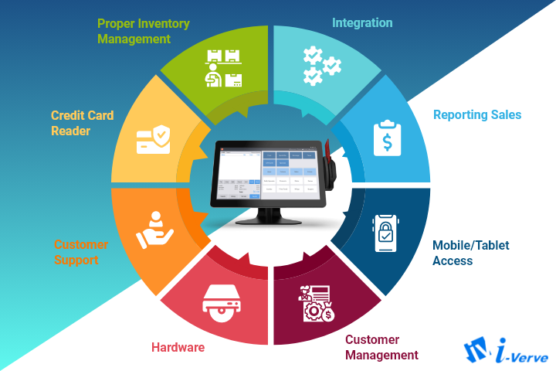

**Figure : 2**

The users here include:

• Administrators of the system who can log in and modify System user management

• Staff who are responsible for processing sale

The system will include:

• A user-friendly interface

• A database: to store all the information

The users will interact with the system through an interface by giving inputs. The input then will then be processed by the system, giving the information needed by on the input given. The system also stores the processed information from the user in the database.

**Use-Case Diagram of Sales & Inventory Management System**

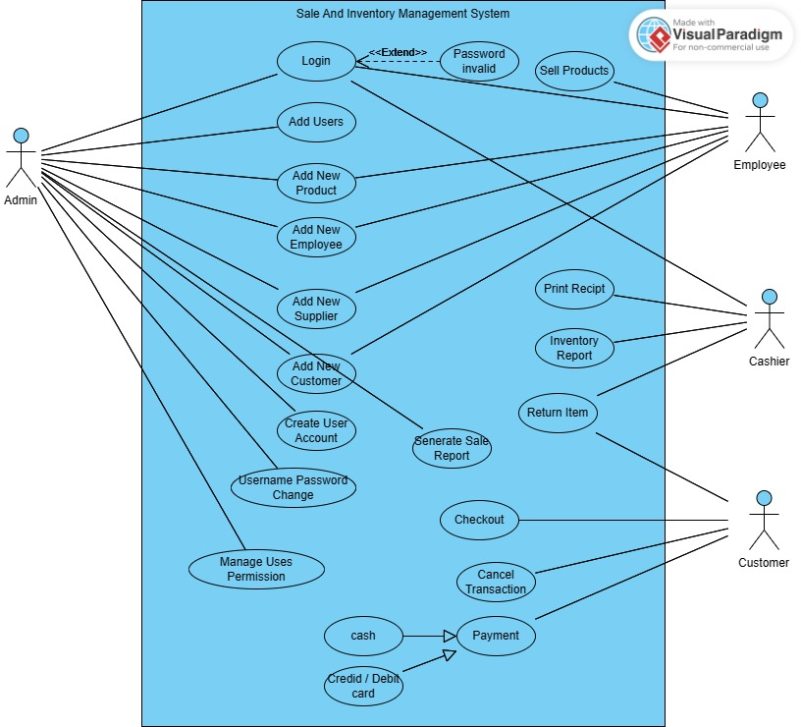

**Figure : 3**

* Introduction to Use-Case Diagrams: A Graphical Overview Use-case diagrams are pivotal tools in the world of software development and systems engineering. They serve as graphical representations that provide a comprehensive overview of a system's functionality and the interactions between its various components, known as actors and use cases. Actors represent entities outside the system who interact with it. They can be users, external systems, or even hardware devices. Use cases, on the other hand, represent specific functionalities or actions that the system can perform. These functionalities are defined based on the system's requirements and user needs. In a use-case diagram, actors are depicted as stick figures, while use cases are shown as ovals. Arrows or lines connect actors to use cases, illustrating the interactions between them. These diagrams are instrumental in conveying the "what" of a system's functionality, focusing on user goals and the value the system provides. Use-case diagrams help stakeholders, including developers, project managers, and end-users, to gain a clear and shared understanding of the system's purpose and behavior. They serve as a foundation for further system design and development activities, aiding in requirements analysis, prioritization, and validation. By visually representing the interactions between actors and use cases, use-case diagrams facilitate effective communication and serve as a vital tool in the early stages of system development, ensuring that the system aligns with user needs and organizational objectives.

**THE APPLICATION**

The Sales and Inventory Management System is a user-friendly desktop application tailored for both technical and non-technical users. Its intuitive design simplifies operations for easy navigation. The login screen, as illustrated in Figure 09, serves as the gateway to the application, distinguishing between user and admin logins to grant access to specific functions. Upon successful login, users are directed to the Home View Dashboard, where essential features are accessible. Notably, the admin login provides access to additional functionalities, including the System User Management feature. This feature, exclusive to administrators, empowers them to manage user accounts effectively. Overall, the system offers a streamlined experience, enhancing productivity and control in sales and inventory management.

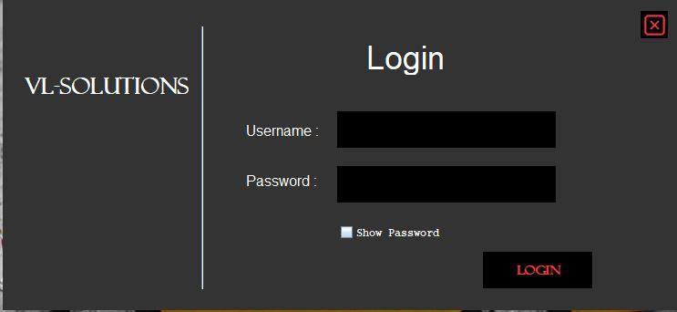

**Figure : 4 User Login Page**

* This is the Login page of the system. The users sign into the system using their ‘Username’ and password. If they do not log in., they can’t use the system. The password can be viewed by ticking the show password.

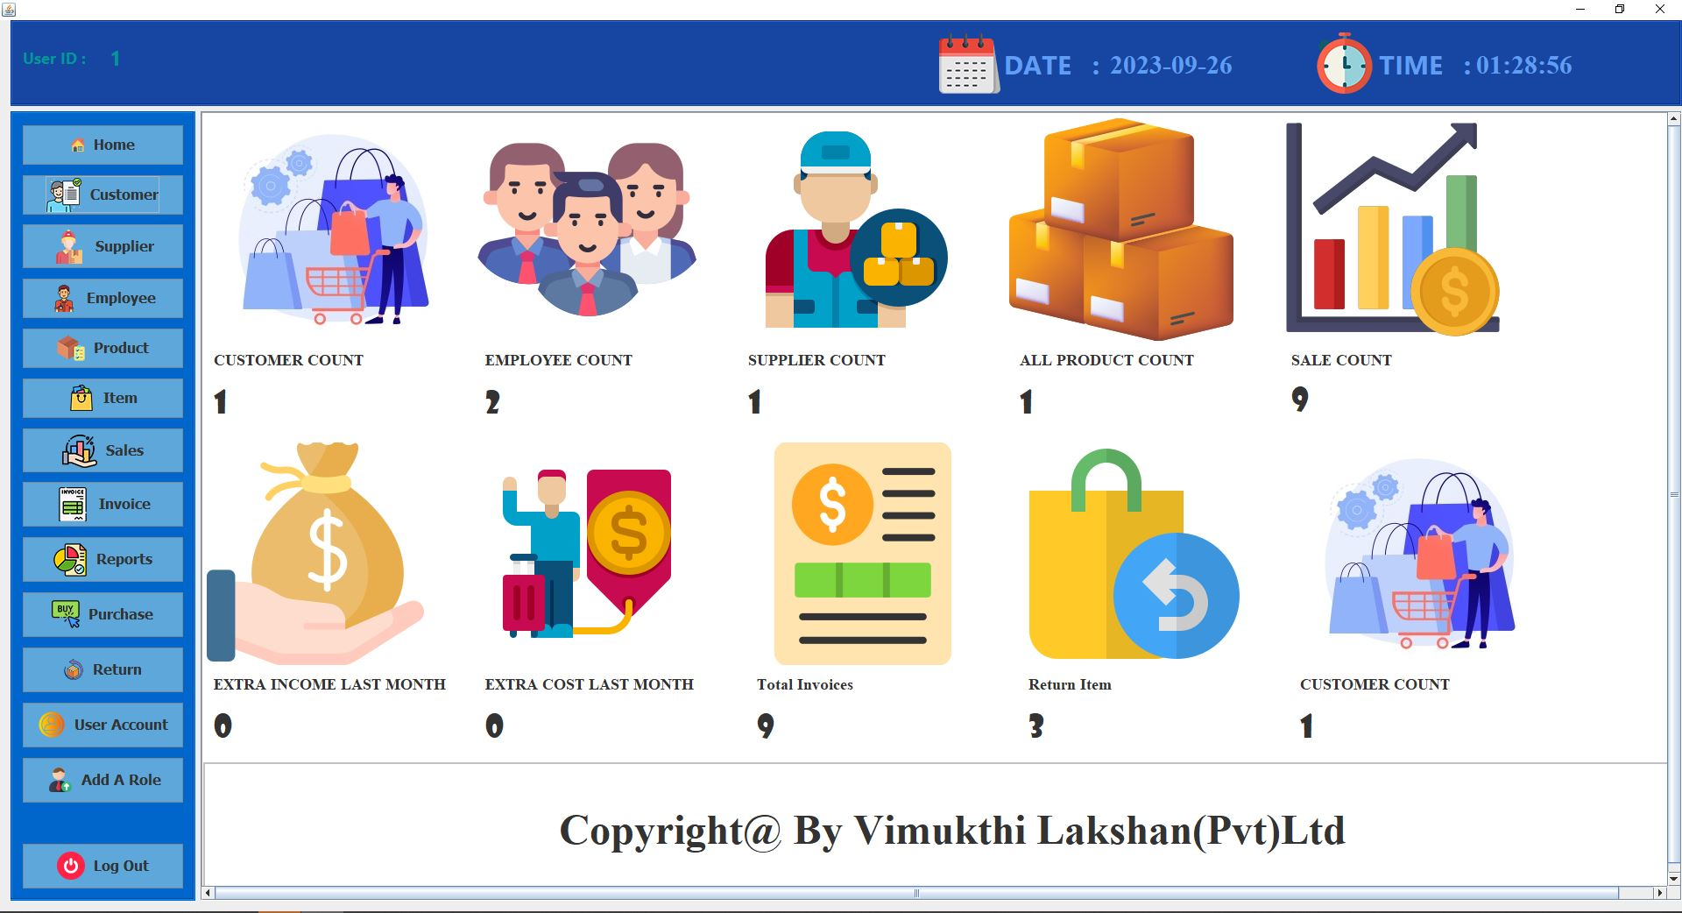

**Figure : 5 User Home Page**

* This is the home page, shows the content interface of Home View Dashboard. Admin and users are allowed to choose functions on the menu page invoice, purchase order, grn, products, stock, customer, supplier, employee, return, logout. However, Admin only visible setting panel.

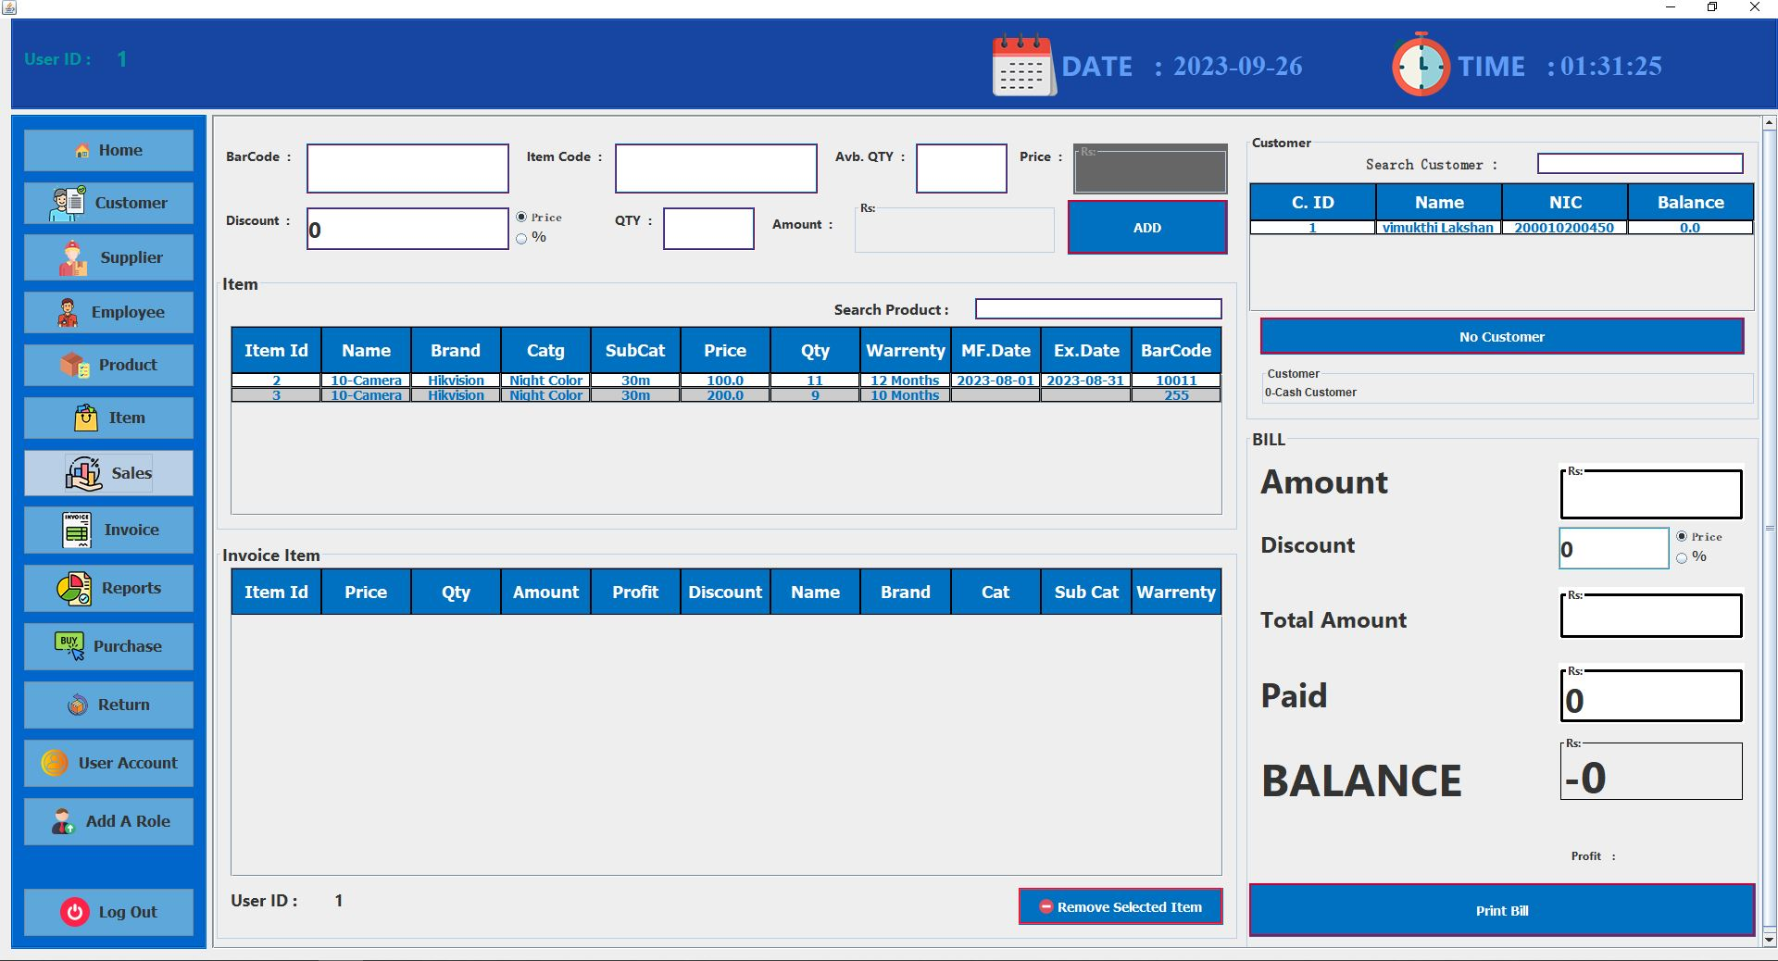

**Figure :6 Sale**

* When you press the sell button, you can go to the place where an invoice is generated. Customers who have already been served can be taken care of on the right side. Or you can register a new customer. And after entering the bar code here, the details of the item will be entered automatically. And after entering the paid amount, the corresponding amount will be deducted and the balance will also be displayed. After entering, a bill can be created and printed.

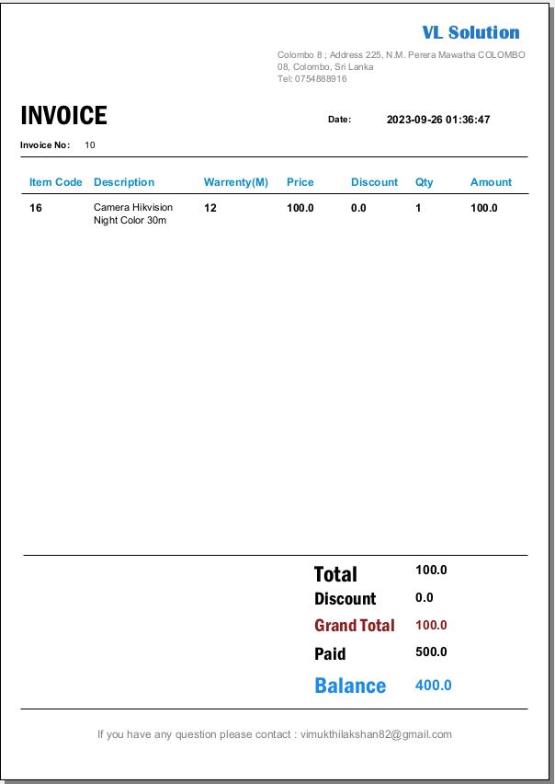

**Figure :6 Invoice**

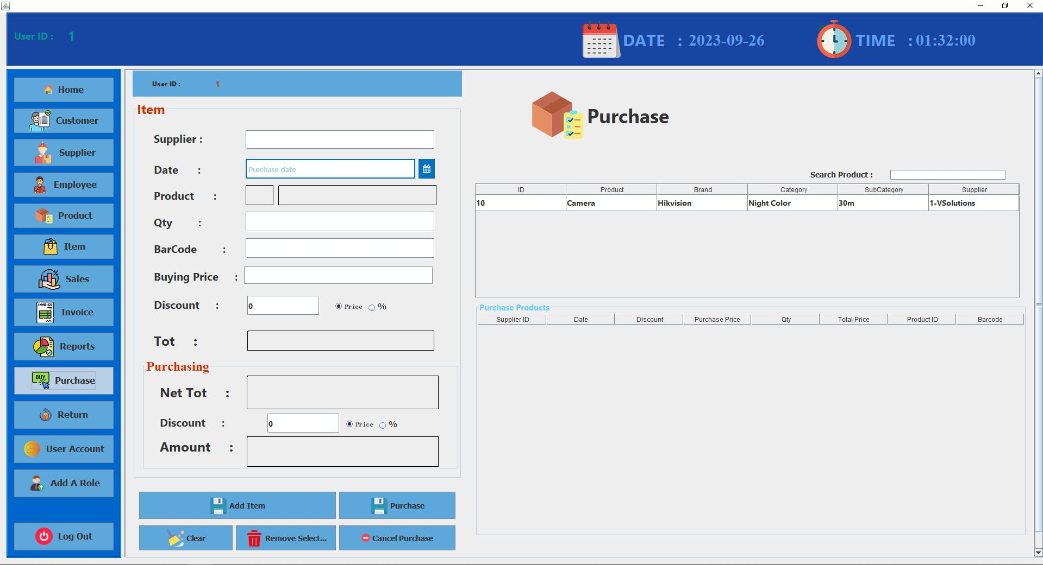

**Figure :7 Purchase**

* Next, when admin / user clicks on the Purchase Order panel, the PO interface will be display as shown in Figure 7. After fill all detail and click on the save button it saves in to database and print a PO report. If user enter wrong data user can delete what they entered by clicking the clear field button.

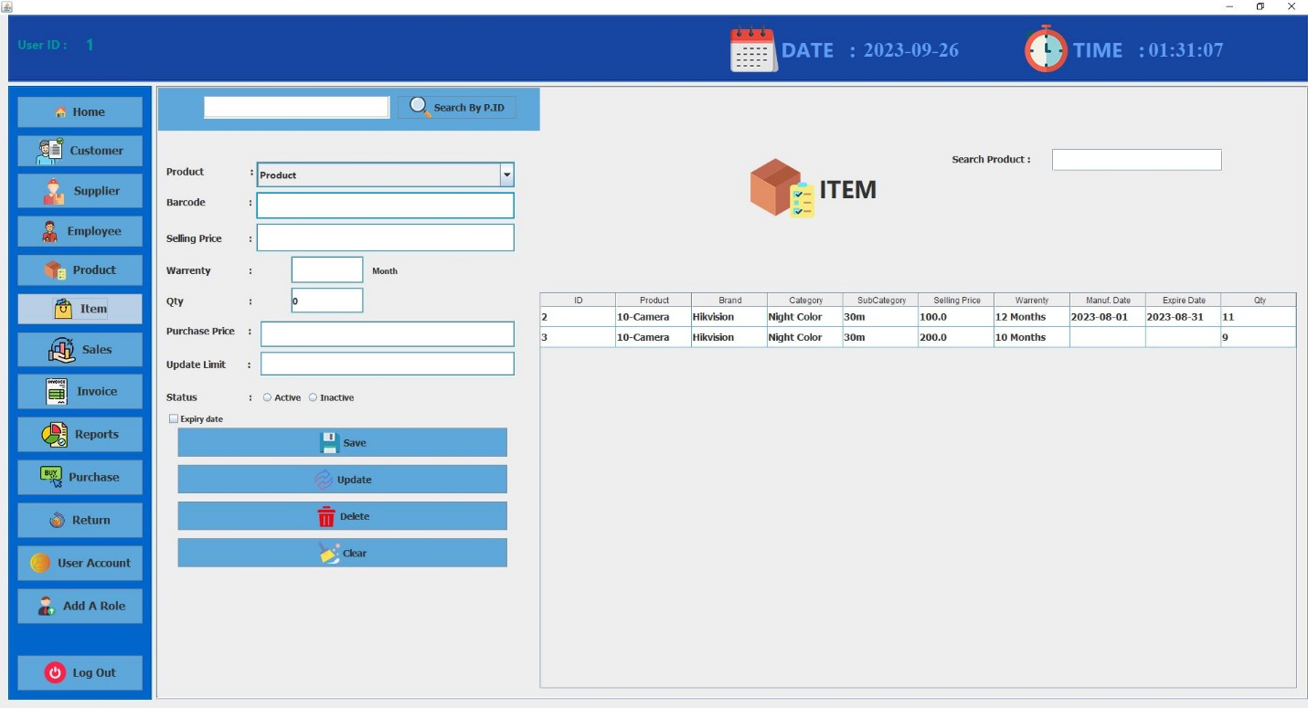

**Figure :8 Item**

